**PowerDesigner导入Excel(可以通过EXCEL的宏完成所需)**

2014-08-21 19:50:21|  分类： [BUBI](http://blog.163.com/pomelo_orange/blog/#m=0&t=1&c=fks_084068080095085064084084082095085095088064086094086075093)|举报|字号 订阅





[下载LOFTER](http://www.lofter.com/app?act=qbbkrzydb_20150408_01)[我的照片书  |](http://yxp.163.com/)

本文转载自computer_yuhan[《PowerDesigner导入Excel(可以通过EXCEL的宏完成所需)》](http://blog.163.com/computer_yuhan/blog/static/226328034201472174452411)

1.编写测试EXCEL:

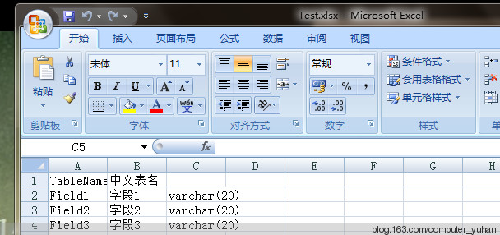

 2.打开PowerDesigner，创建物理模型(Physical Data Model)

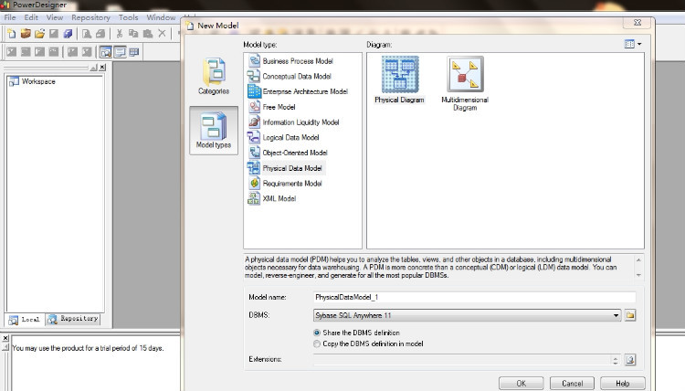

 3.在PowerDesigner菜单栏中，依次点击“Tools ->Excute Commands->Edit/Run Script..”

 Option Explicit     
Dim mdl ' the current model   
Set mdl = ActiveModel   
If (mdl Is Nothing) Then     
  MsgBox "There is no Active Model"   
End If   
    
Dim HaveExcel   
Dim RQ    
RQ = vbYes 'MsgBox("Is Excel Installed on your machine ?", vbYesNo + vbInformation, "Confirmation")   
If RQ = vbYes Then    
   HaveExcel = True    
' Open & Create Excel Document   
 Dim x1 '    
  Set x1 = CreateObject("Excel.Application")  
  x1.Workbooks.Open "D:/Test.xlsx"   
  x1.Workbooks(1).Worksheets("Sheet1").Activate   
Else  
   HaveExcel = False   
End If   
    
a x1, mdl   
    
sub a(x1,mdl)   
dim rwIndex   
dim tableName   
dim colname   
dim table   
dim col   
dim count   
    
'on error Resume Next   
For rwIndex = 1 To 4 step 1     
    With x1.Workbooks(1).Worksheets("Sheet1")  
  'MsgBox "生成数据表结构共计1 ="+CStr(.Cells(2,2).Value ), vbOK + vbInformation, "表"   
   If .Cells(rwIndex, 1).Value = "" Then   
       Exit For   
   End If    
  If .Cells(rwIndex, 3).Value = "" Then   
    set table = mdl.Tables.CreateNew   
        table.Name = .Cells(rwIndex , 1).Value   
        table.Code = .Cells(rwIndex , 2).Value   
        count = count + 1    
   Else     
    colName = .Cells(rwIndex, 1).Value   
    set col = table.Columns.CreateNew    
   'MsgBox .Cells(rwIndex, 1).Value, vbOK + vbInformation, "列"   
    col.Name = .Cells(rwIndex, 1).Value   
    'MsgBox col.Name, vbOK + vbInformation, "列"  
     col.Code = .Cells(rwIndex, 2).Value   
    col.Comment = .Cells(rwIndex,1).Value    
    col.DataType = .Cells(rwIndex, 3).Value   
   End If   
  End With   
Next   
    
MsgBox "生成数据表结构共计" + CStr(count), vbOK + vbInformation, "表"   
   
Exit Sub   
End sub   
5.测试  
5.1用的EXCEL：Test.xlsx放入D盘根目录，注意这个路径要与脚本中的路径一致

5.2运行脚本  
5.3检查导入效果

